Python

1. How to get python on windows 10

<https://www.liquidweb.com/kb/how-to-setup-a-python-virtual-environment-on-windows-10/>

1. how to get pip

<https://www.liquidweb.com/kb/install-pip-windows/>

Successfully installed Virtualenv

Installed version virtualenv-16.7.9

Follow instructions from the image downwards………..

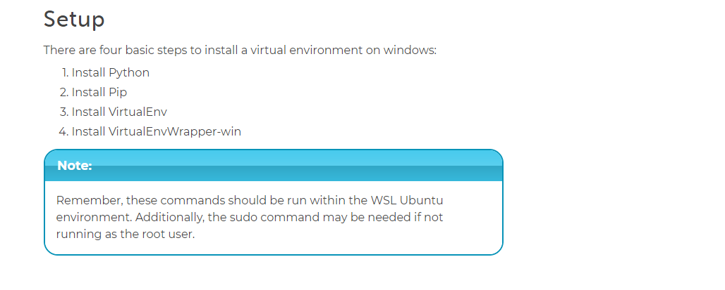

<https://www.liquidweb.com/kb/tag/python-pip/>

Request package for python

Beautiful soup

<https://www.crummy.com/software/BeautifulSoup/>

YouTube video

<https://www.youtube.com/watch?v=0_VZ7NpVw1Y>